A performance comparison
of search trees

User Guide

Przemysław Rosiński
Piotr Janaszek

Faculty of Mathematics and Information Science
Warsaw University of Technology

9 January 2012

DOCUMENT METRIC

Project: | A performance comparison of search trees |  |  | Company: | WUT
Name: | User Guide
Topics: | Interface overview, usage
Author: | Przemysław Rosiński, Piotr Janaszek
File: | SearchTreesPerformance_UserGuide.pdf
Version no: | 1.0 | Status: | Working | Opening date: | 1.01.2012
Summary: | How to use the application
Authorized by: |  |  |  | Last modification date: | 8.01.2012

HISTORY OF CHANGES
Version | Date | Author | Description
0.0.1 | 1.01.2012 | Przemysław Rosiński | Created document
0.2 | 1.01.2012 | Przemysław Rosiński | Created Preface
0.4 | 2.01.2012 | Przemysław Rosiński,  Piotr Janaszek | Created Interface Overview
0.5 | 2.01.2012 | Piotr Janaszek | Created Launch
0.7 | 2.01.2012 | Przemysław Rosiński | Created Usage
0.8 | 5.01.2012 | Piotr Janaszek | Added Batch Process and Display Tree to Usage
0.9 | 7.01.2012 | Piotr Janaszek | Created Troubleshooting
1.0 | 8.01.2012 | Przemysław Rosiński | Fixed mistakes and changed document formatting

Table of Contents
PREFACE 4
launch 4
Interface overview 4
Main window 5
Create mode 6
Search mode 7
Batch Process mode 8
Open File dialog 9
Add Tree dialog 9
USAGE 10
Load input file 10
Add tree from file 10
Add tree manually 11
Remove tree 11
Add node 11
Remove node 12
Search element 12
Result set 12
Batch process 13
Display tree 14
Not allowed actions 14
Troubleshooting 15
On user's own 15
More help 15

PREFACE
Developed application shows capabilities of search tree libraries. Libraries are of C# generic type standardized to DLL format.
Program is able to retrieve necessary data about tree nodes manually by user input via GUI (Graphical User Interface) and/or automatically from external CSV file.
The application graphically presents structure of the tree to the user. Result of searching algorithm execution should are also visualized by marking the path from root to the particular node.
Program gives possibility to compare the performance of search trees using external tool. Application exports external file compliant with CSV format.

launch
Before launching the application, make sure that in the same directory there are:
- application executable file,
- ForRest.Provider DLL library (necessary for application startup) and Microsoft.GLEE, Microsoft.GLEE.Drawing, Microsoft.GLEE.GraphViewerGDI DLL libraries (needed for displaying trees in GLEE graph form).
- Plugins folder with DLL libraries containing trees projects,

Interface overview
In this section the reader can get known the application interface layout. This will help with using the application and understand description of steps in next sections.
The main window of the running program consists of three parts.
- On the top, there is menu strip with four items, which provide main functionalities of the program.
- Below, there is tool strip consisting of seven buttons with icons on them. These buttons correspond to items under menu, but they provide faster access and intuitiveness.
- The biggest part is prescribed for child windows corresponding to modes of the program. Depending on the mode, additional controls are available for performing actions, collecting data from user and presenting results.

Main window
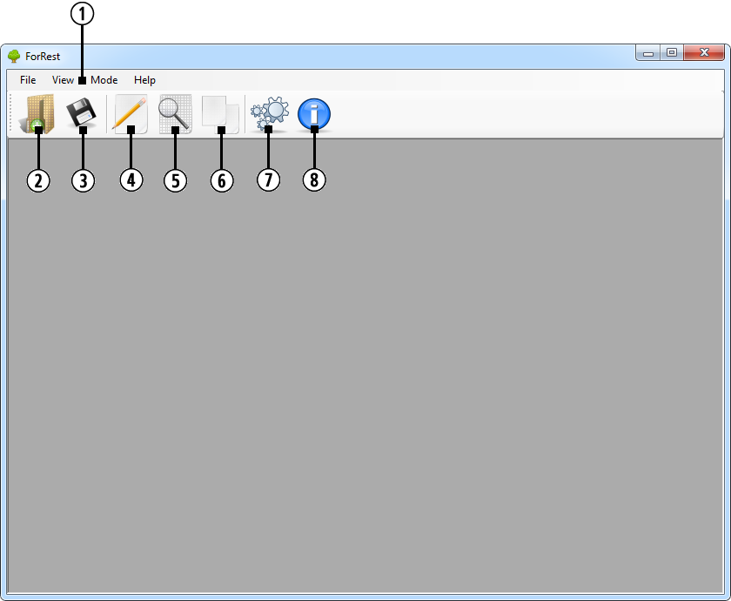
1 – Menu strip. Contains of four items: File, View, Mode and Help.
2 – Open file button.
3 – Export to file button.
4 – Create button.
5 – Search button.
6 – Batch process button.
7 – Loaded modules button.
8 – About button.

Create mode
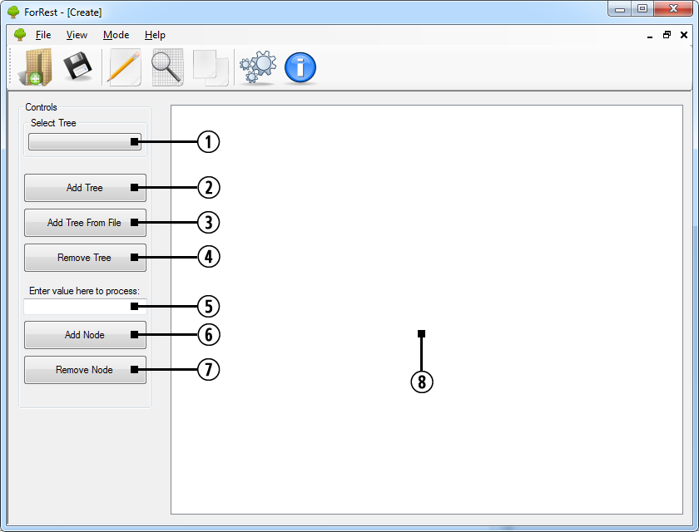
1 – Select tree combo-box.
2 – Add tree button.
3 – Add tree from file button.
4 – Remove tree button.
5 – Value text-box.
6 – Add node button.
7 – Remove node button.
8 – Graph panel.

Search mode
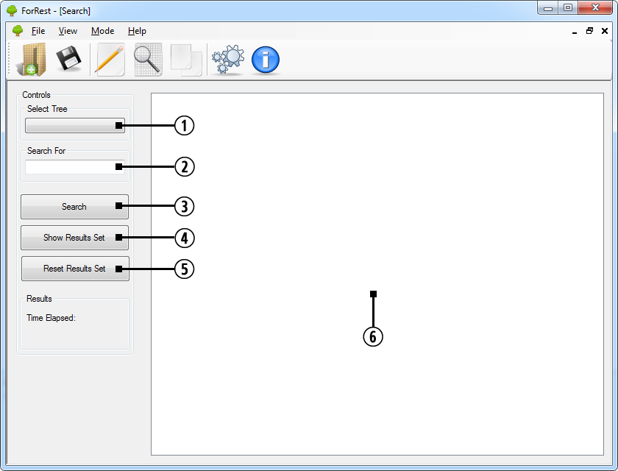
1 – Select tree combo-box.
2 – Value text-box.
3 – Search button.
4 – Show results button.
5 – Reset results button.
6 – Graph panel.

Batch Process mode
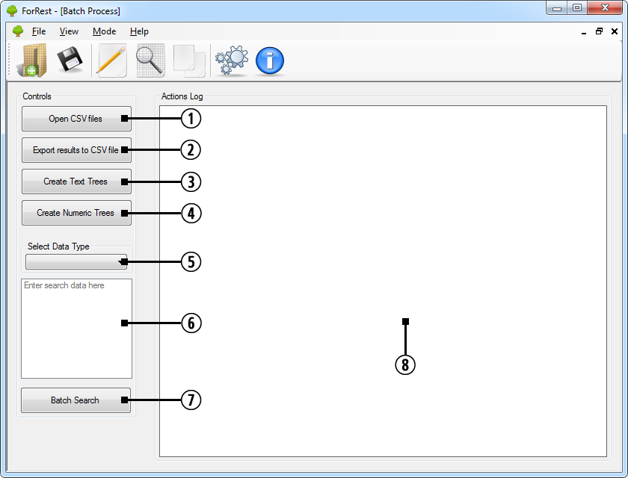
1 – Open files button.
2 – Export results button.
3 – Create text trees button.
4 – Create numeric trees button.
5 – Data type combo-box.
6 – Values text-box.
7 – Batch search button.
8 – Action log panel.

Open File dialog
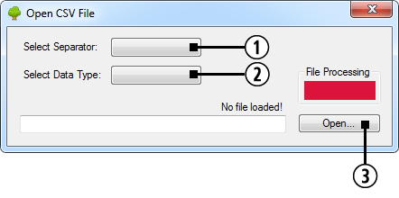
1 – Separator combo-box.
2 – Data type combo-box.
3 – Open button.

Add Tree dialog
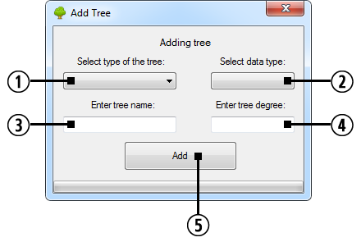
1 – Tree type combo-box.
2 – Data type combo-box (optional).
3 – Tree name text-box.
4 – Degree text-box (optional, depending on selected tree type).
5 – Add button.

USAGE

Load input file
To load data from external file user should:
- click Open file button in tool strip or
- select Menu > File > Open File.
Open File dialog will appear in which user should:
- select separator used in CSV file (comma, colon or semicolon) and
- select data type (text or numeric).
Previously disabled Open button will be enabled. After clicking it standard Windows open file dialog will be displayed for choosing the file from disk.
If file is processed correctly, data is loaded and ready to use.

Add tree from file
To add tree from external file application must be in Create mode. User should:
- click Create button in tool strip or
- select Menu > Mode > Create.
Child window will appear inside main window in which user should click Add tree from file button. Add Tree dialog without Data type combo-box will appear in which user should:
- select tree type and
- type tree name and
- enter degree of the tree (optional, depending on selected tree type).
Previously disabled Add button will be enabled. After clicking it tree with nodes specified in input file is created and added to Select tree combo-box in Create child window.
NOTE: Possibility of performing not allowed action. User cannot add tree from file, when no file is previously loaded.

Add tree manually
To add tree manually application must be in Create mode. User should:
- click Create button in tool strip or
- select Menu > Mode > Create.
Child window will appear inside main window in which user should select tree from Add tree button. Add Tree dialog with Data type combo-box will appear in which user should:
- select tree type and
- select data type and
- type tree name and
- enter degree of the tree (optional, depending on selected tree type).
Previously disabled Add button will be enabled. After clicking it tree is created and added to Select tree combo-box in Create child window.

Remove tree
To remove tree application must be in Create mode. User should:
- click Create button in tool strip or
- select Menu > Mode > Create.
Child window will appear inside main window in which user should select one of previously created trees using Select tree combo-box.
Previously disabled Remove tree button will be enabled. After clicking it tree is removed from Select tree combo-box and cannot be restored.

Add node
To add node to the tree application must be in Create mode. User should:
- click Create button in tool strip or
- select Menu > Mode > Create.
Child window will appear inside main window in which user should select one of previously created trees using Select tree combo-box.
Previously disabled Add node button will be enabled. Data to be added should be entered into Value text-box. After clicking Add node button node is added to the tree.
NOTE: Possibility of performing not allowed action. User cannot add node to tree with numeric data type, when content in Value text-box cannot be parsed to a number.

Remove node
To remove node from the tree application must be in Create mode. User should:
- click Create button in tool strip or
- select Menu > Mode > Create.
Child window will appear inside main window in which user should select one of previously created trees using Select tree combo-box.
Previously disabled Remove node button will be enabled. Data to be removed should be entered into Value text-box. After clicking Remove node button node is removed from the tree.
NOTE: Possibility of performing not allowed action. User cannot remove node from tree with numeric data type, when content in Value text-box cannot be parsed to a number.

Search element
To search element in the tree application must be in Search mode. User should:
- click Search button in tool strip or
- select Menu > Mode > Search.
Child window will appear inside main window in which user should select one of previously created trees using Select tree combo-box.
Previously disabled Search button will be enabled. Data to be searched should be entered into Value text-box. After clicking Search button node is searched in the tree and searching performance information is displayed in the left panel on the bottom and added to result set.
NOTE: Possibility of performing not allowed action. User cannot search element in tree with numeric data type, when content in Value text-box cannot be parsed to a number.

Result set
To manage result of searching element in trees application must be in Search mode. User should:
- click Search button in tool strip or
- select Menu > Mode > Search.
Child window will appear inside main window.
After clicking Show results button window with result set is displayed.
After clicking Reset results button result set is cleared.

To save result of searching to external file user should:
- click Export to file button in tool strip or
- select Menu > File > Export to File.
Standard Windows save open file dialog will be displayed for choosing the location for the file to be saved on disk.
NOTE: Possibility of performing not allowed action. User cannot save result set to external file, when result set is empty.

Batch process
Batch process in independent from actions performed in Create and Search modes, i.e. no trees created in Create mode and no results of searching done in Search mode will be considered or processed during batch process.
To process searching in batch the tree application must be in Batch Process mode. User should:
- click Batch Process button in tool strip or
- select Menu > Mode > Batch Process.
Child window will appear inside main window.
To load files with data user should click Open files button. Open File dialog will appear in which user should:
- select separator used in CSV files (comma, colon or semicolon) and
- select data type (text or numeric).
Previously disabled Open button will be enabled. After clicking it standard Windows open file dialog with multi-selecting enabled will be displayed for choosing files from disk.
Loading files can be done repeatedly in series.
If text data was loaded, Create text trees button will be enabled and Text value is added to Data type combo-box.
If numeric data was loaded, Create numeric trees button will be enabled Numeric value is added to Data type combo-box.
To create trees user should click one or both of enabled above-mentioned buttons.
To enter element to be searched user should select data type from Data type combo-box and populate Values text-box with desired elements.
After clicking Batch search button all the trees of selected data type will be searched for all the elements in Values text-box and searching performance information is added to result set.
NOTE: Possibility of performing not allowed action. User cannot search element in trees with numeric data type, when content in Values text-box cannot be parsed to a number.
After performing batch searching previously disabled Export results button will be enabled. After clicking it standard Windows save open file dialog will be displayed for choosing the location for the file to be saved on disk.
During creating and executing batch process all the information is displayed to the user in Action log panel as a text.

Display tree
During managing trees in Create and Search modes, tree is visualized in Graph panel.
There are three implemented methods of displaying tree:
- tree-view using Windows Form built-in functionality,
- graph created by the developers of this application,
- graph created using Microsoft GLEE tool.
Default visualization is tree-view. To change it user should select:
- Menu > View > Tree View / Graph / GLEE Graph.
In case of Search mode enabled, after searching existing element in the tree path from the root to searched element is marked with thicker green line.
NOTE: When Microsoft.GLEE, Microsoft.GLEE.Drawing, Microsoft.GLEE.GraphViewerGDI DLL libraries cannot be found in application directory, GLEE graph cannot be created. Items in Menu > View are limited to Tree View and Graph.

Not allowed actions
During using the application, the user can attempt to perform not allowed actions. In such cases, program blocks execution of the action and informs the user why it is not allowed by tool-tip pop-up or error message.

Troubleshooting

On user's own
Try to do the following when application does not work as you would expect.
Problem | Possible solution
Application does not launch | Make sure that in the same directory as executable file there is ForRest.Provider DLL library
GLEE graph does not exist in Menu > View | Make sure that in the same directory as executable file there are Microsoft.GLEE, Microsoft.GLEE.Drawing and Microsoft.GLEE.GraphViewerGDI DLL libraries
My tree does not exist in Tree type combo-boxes | Make sure that in the same directory as executable file there is a folder Plugins with your DLL library and check if it is loaded by the application by clicking  Loaded modules button in tool strip  or by selecting  Menu > Help > Loaded Modules
Application does not allow me to perform an action | Make sure that you are not performing not allowed action and you are following user guide and pop-up tool-tips
Application does not process input file | Make sure that input file is compliant with CSV format
Application does not load data from processed input file | Make sure that input file is compliant with CSV format and you selected proper separator and data type

More help
In case of problems you cannot solve, e-mail us with as much information as it is possible.
Contact:
- Przemysław Rosiński – rosinskip@student.mini.pw.edu.pl
- Piotr Janaszek – janaszekp@student.mini.pw.edu.pl

